**Exercise 1: Implementing the Singleton Pattern**

**Code:**

Logger.java:

public class Logger {

private static Logger *instance* = new Logger();

private Logger() {

System.*out*.println("Logger instance created.");

}

public static Logger getInstance() {

return *instance*;

}

public void log(String message) {

System.*out*.println("Log: " + message);

}

}

Main.java:

public class Main {

public static void main(String[] args) {

Logger logger1 = Logger.*getInstance*();

Logger logger2 = Logger.*getInstance*();

logger1.log("Starting the application.");

logger2.log("Application running.");

if (logger1 == logger2) {

System.*out*.println("Both logger1 and logger2 refer to the same instance.");

}

else {

System.*out*.println("Different instances detected.");

}

}

}

**Output:**

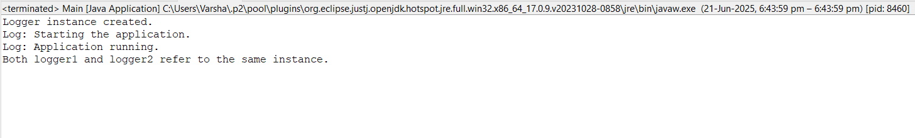

**Exercise 2: Implementing the Factory Method Pattern**

**Code:**

Document.java:

public interface Document {

void open();

}

WordDocument.java:

public class WordDocument implements Document {

@Override

public void open() {

System.out.println("Opening Word document...");

}

}

PdfDocument.java:

public class PdfDocument implements Document {

@Override

public void open() {

System.out.println("Opening PDF document...");

}

}

ExcelDocument.java:

public class ExcelDocument implements Document {

@Override

public void open() {

System.out.println("Opening Excel document...");

}

}

DocumentFactory.java:

public abstract class DocumentFactory {

public abstract Document createDocument();

}

WordDocumentFactory.java:

public class WordDocumentFactory extends DocumentFactory {

@Override

public Document createDocument() {

return new WordDocument();

}

}

PdfDocumentFactory.java:

public class PdfDocumentFactory extends DocumentFactory {

@Override

public Document createDocument() {

return new PdfDocument();

}

}

ExcelDocumentFactory.java:

public class ExcelDocumentFactory extends DocumentFactory {

@Override

public Document createDocument() {

return new ExcelDocument();

}

}

Main.java:

public class Main {

public static void main(String[] args) {

DocumentFactory wordFactory = new WordDocumentFactory();

Document wordDoc = wordFactory.createDocument();

wordDoc.open();

DocumentFactory pdfFactory = new PdfDocumentFactory();

Document pdfDoc = pdfFactory.createDocument();

pdfDoc.open();

DocumentFactory excelFactory = new ExcelDocumentFactory();

Document excelDoc = excelFactory.createDocument();

excelDoc.open();

}

}

**Output:**

